Best Practice I: Cleaning of college campus and Awareness Generation

Dated: 10.01.2017
Objectives of the practice:
- To clean the college surroundings along with the medicinal garden.
- To generate the awareness among students of conserving natural plant vegetation within local areas.
Organised by: Nature’s Club, Rabindra Mahavidyalaya, Champadanga, Hooghly.
Practice:
The activity was carried out by a team of fifty-sixty students of Bioscience departments along with teachers and staff members together with the Nature’ Club unit of the College. The event was organised from time to time also with the support of NSS units of College with an attempt of cleaning the College campus and restore the natural resources, an asset of the College and humankind. For the same, an awareness regarding conservation of our natural resources and nature instigated among students.
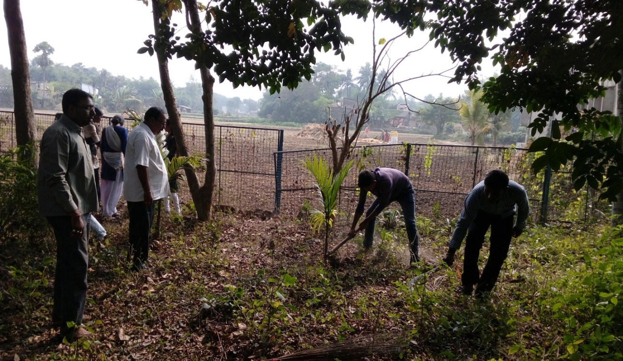
The students were divided in several groups with five to six candidates in each group. Their task was divided and thee groups were given the task of cleaning the Medicinal Garden within the College. The students cleaned the unwanted weeds, dig out the areas of the already planted trees, watered them properly. Apart from this they also studied about the plants with medicinal importance, in order to spread their uses among the common people of the village.

Students working on the eastern side of the medicinal garden, accompanied by teachers

Apart from cleaning of the Garden, other portions of the College campus were cleaned such as cycle stand areas, other two small garden units in order to plant more medicinal herbs and generate a feeling of nature awareness among all. All the garbage and wastes were collected, cleaned methodically in a proper manner. Extra weeds were collected from the medicinal plant section and plants were watered and maintained in proper manner.
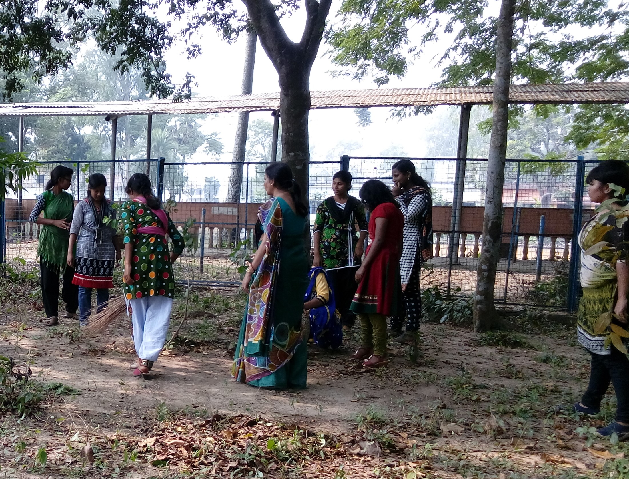
Students cleaning the cycle stand with full enthusiasm and collecting the wastes from the areas

Outcome:

- At last, students along with their teachers’ made oath to maintain the slogan of Nature’ club- GO GREEN within the college campus and its surroundings.
- Students were so interested that they request for organizing such event in future.

